Lab Exam Midterm:

Task 1: SELECT \* FROM SALGRADE;

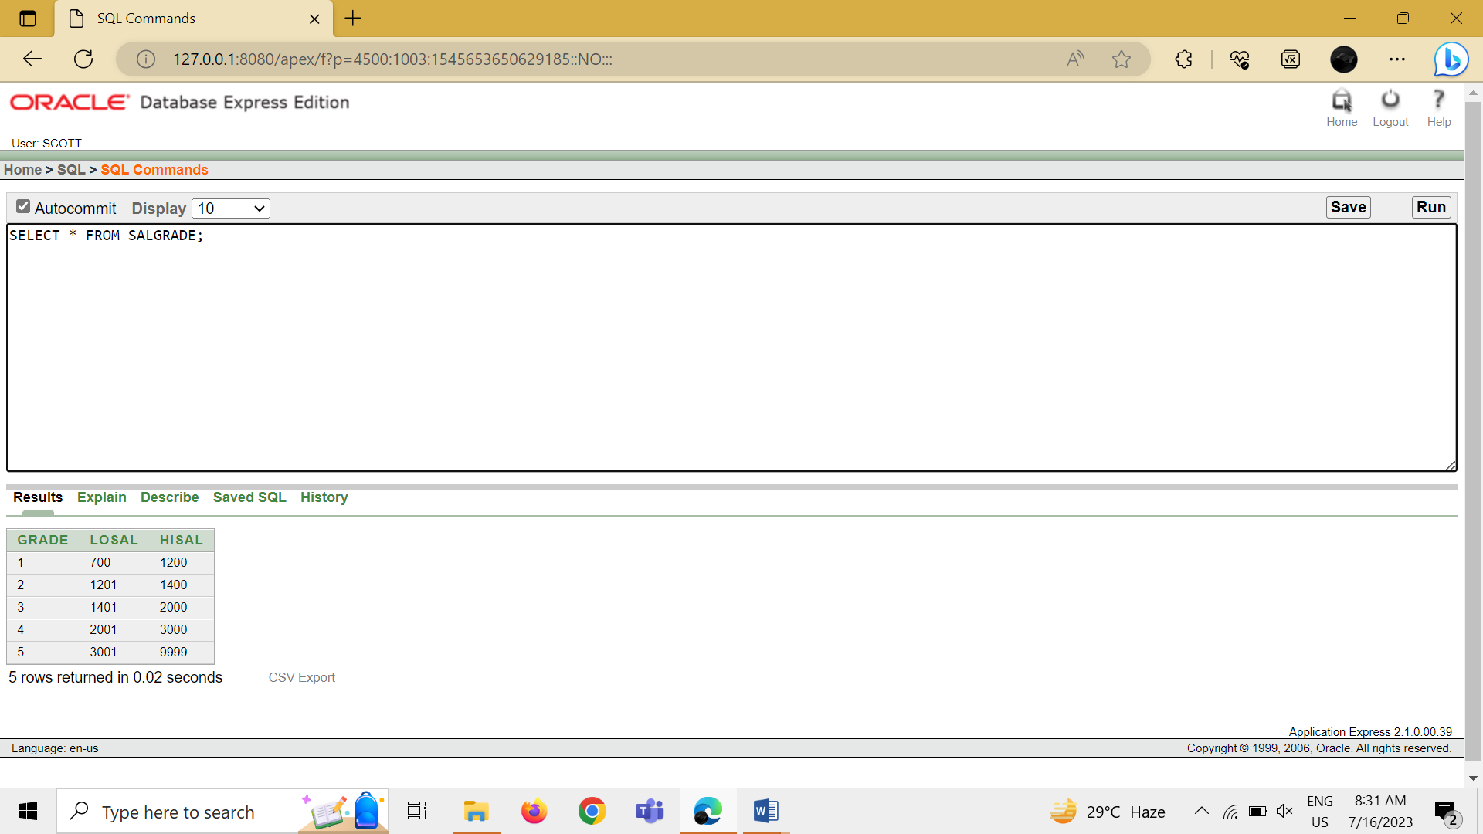

Task 2: SELECT DEPTNO FROM DEPT;

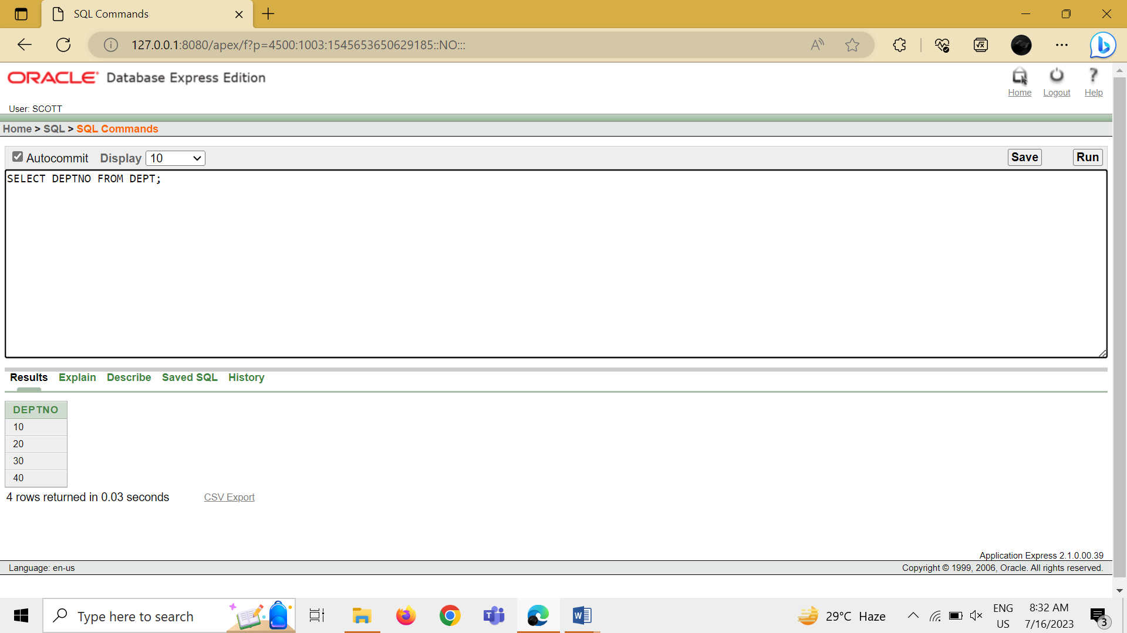

Task 3: SELECT ENAME, SAL SALARY, SAL \* 0.05 AS "5% INCREMENT" FROM EMP;

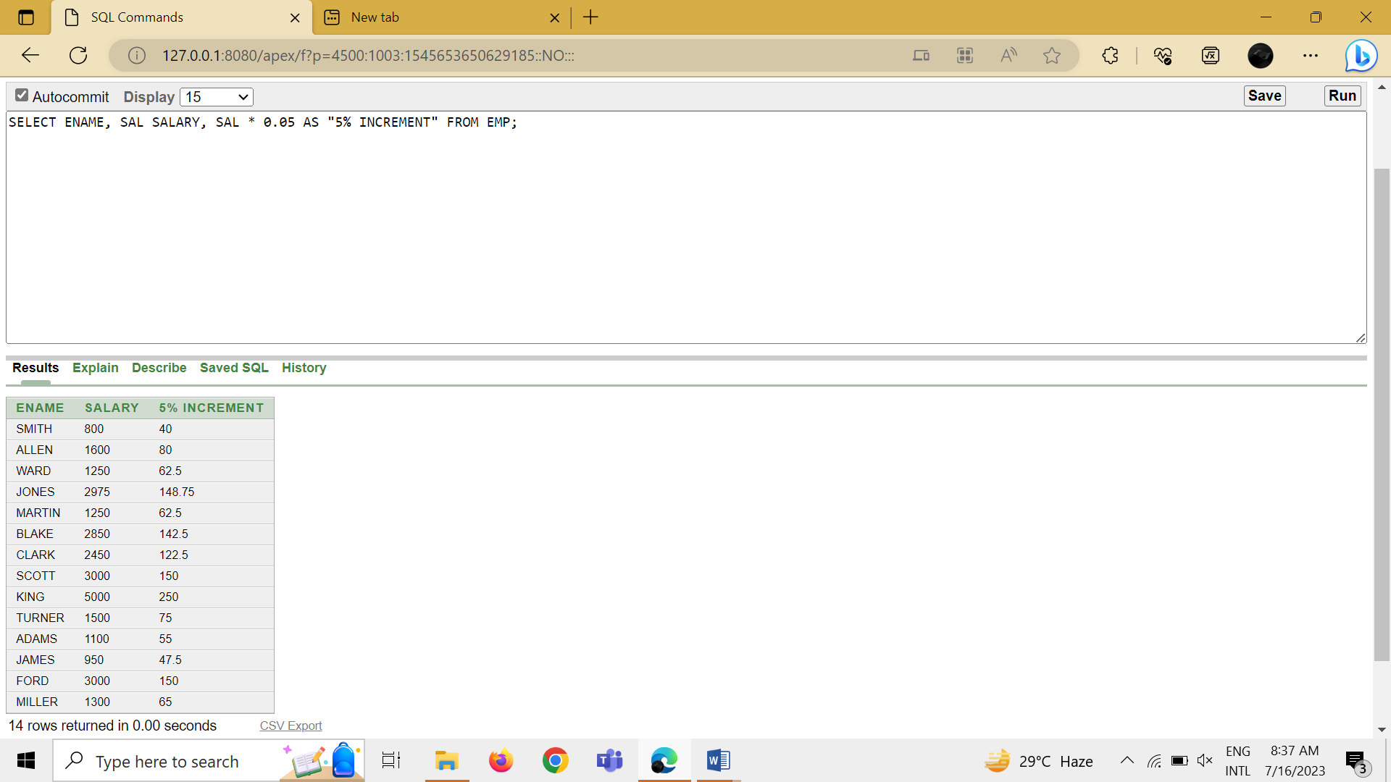

Task 4: SELECT ENAME, SAL + (SAL \* 0.05) AS "SALARY AFTER 5% INCREMENT" FROM EMP;

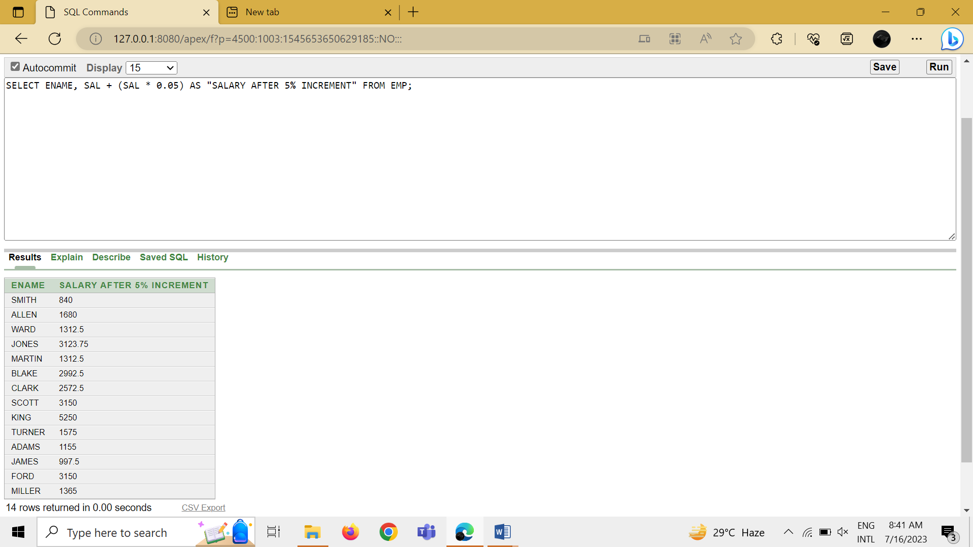

Task 5: SELECT \* FROM EMP WHERE ENAME = 'BLAKE';

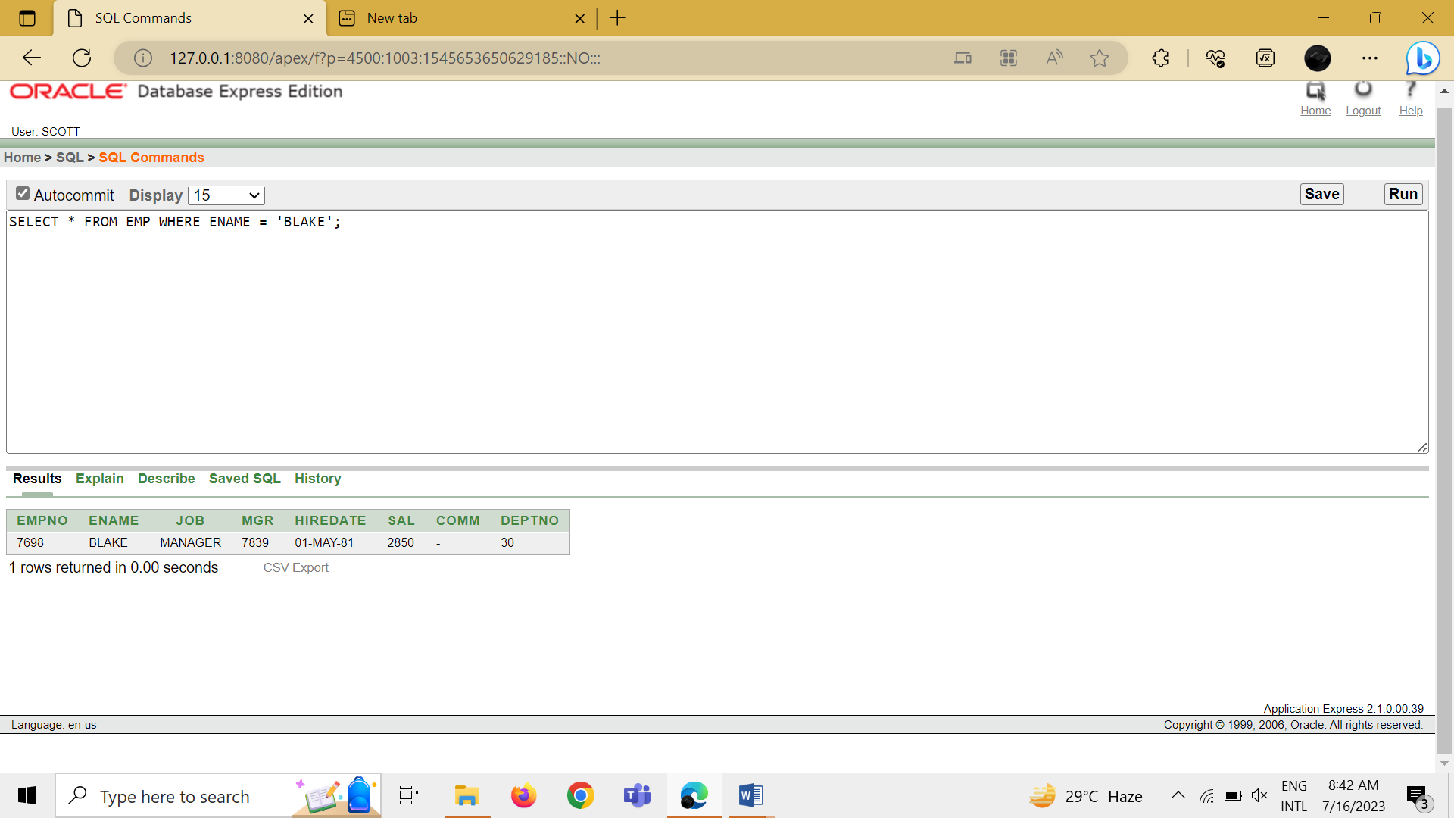

Task 6: SELECT ENAME || ' is hired on ' || HIREDATE || ' as a ' || JOB FROM EMP;

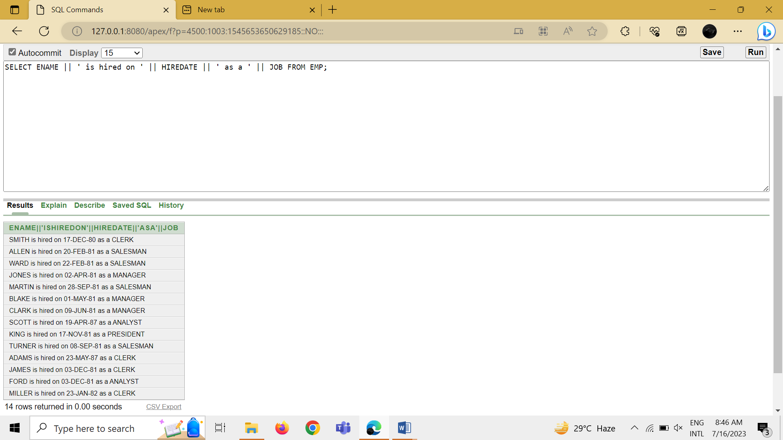

Task 7.1: DESCRIBE EMP;

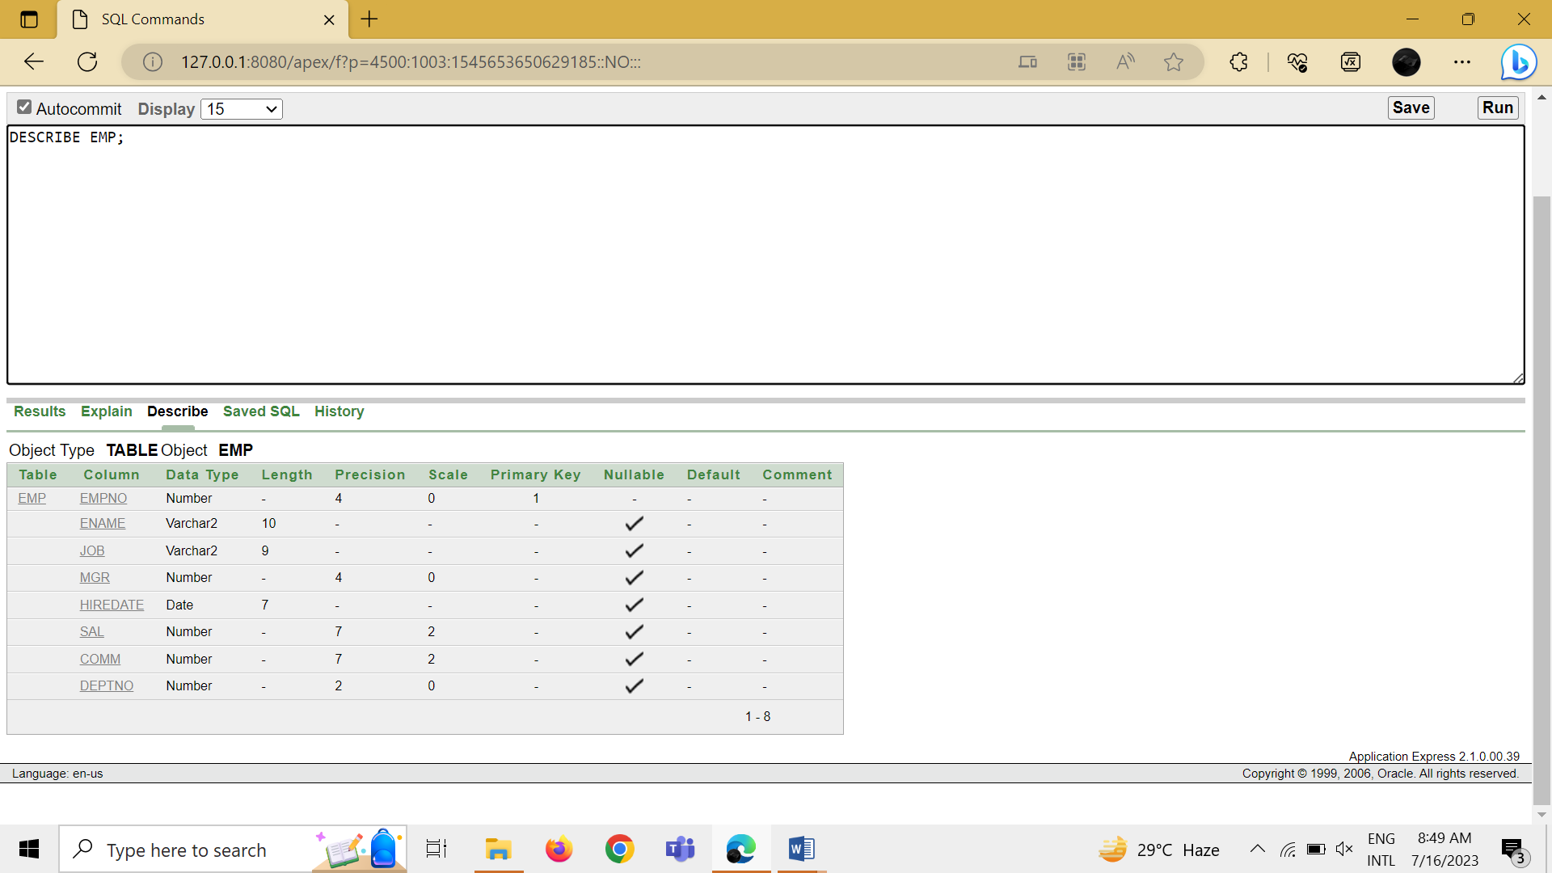

Task 7.2: DESCRIBE DEPT;

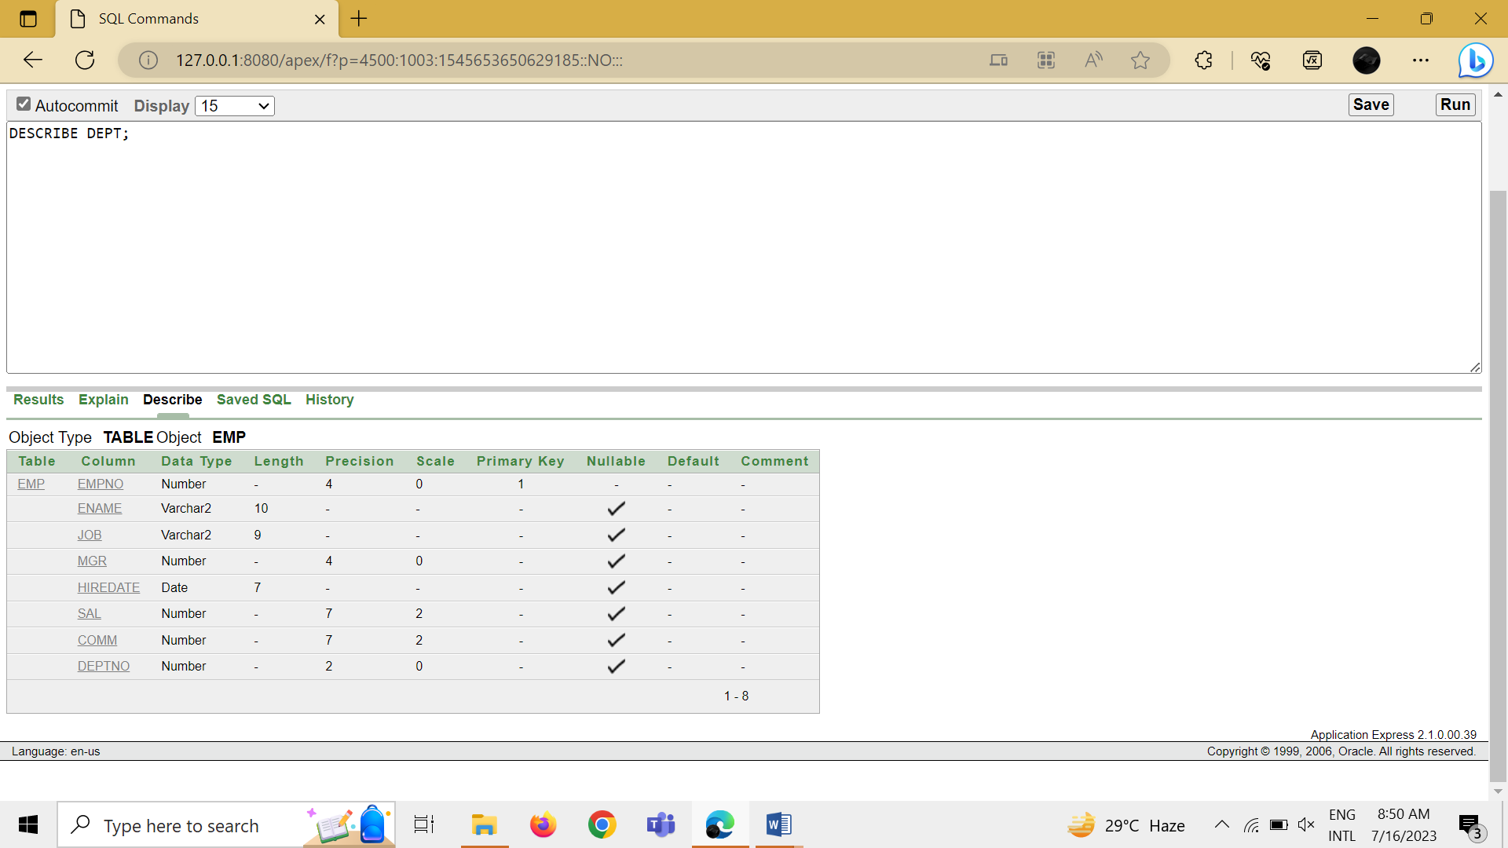

Task 7.3: DESCRIBE BONUS;

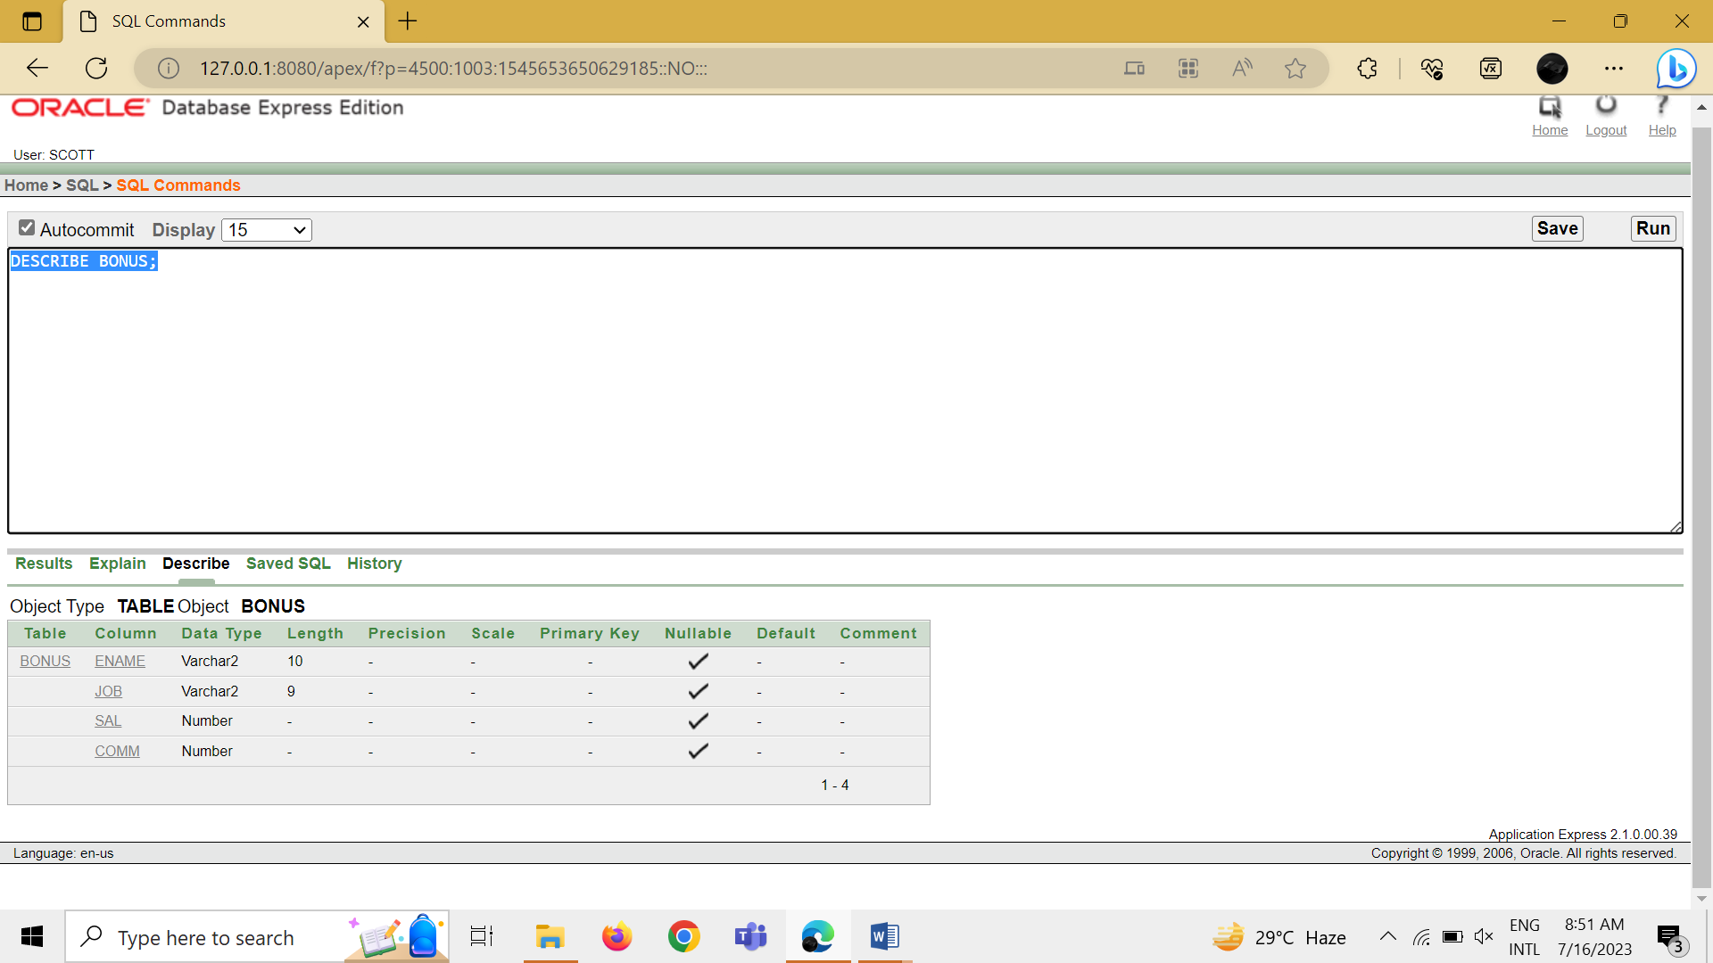

Task 7.4: DESCRIBE SALGRADE;

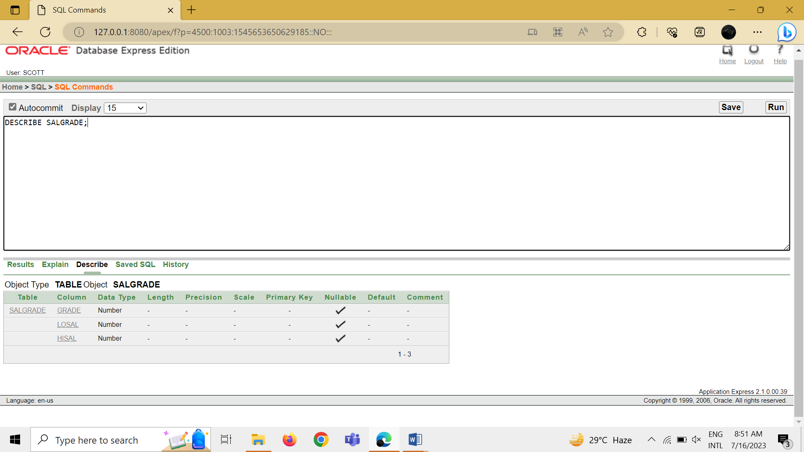

Task 8: SELECT DISTINCT JOB FROM EMP;

